The Intergroup Newsletter is published periodically for your enjoyment and information. The opinions expressed in this publication are those of the editorial staff and contributors, not necessarily of the A.A. Fellowship as a whole. A.A.® and Alcoholics Anonymous® are registered trademarks of A.A. World Services, Inc.
Published by Intergroup Central Office
June 2019
District 14 Intergroup News
06/2019

Step 6: Were entirely ready to have God remove all these defects of character.
Tradition 6: An A.A. group ought never endorse, finance or lend the A.A. name to any related facility or outside enterprise, lest problems of money, property and prestige divert us from our primary purpose.

Concept 6. The Conference recognizes that the chief initiative and active responsibility in most world service matters should be exercised by the trustee members of the Conference acting as the General Service Board.

A 6th Step prayer:

"God, Thank you for removing my fear and for showing me the truth about myself. Father, I need your help to become willing to let go of the things in me which continue to block me off from you. Please grant me your Grace Lord and make me willing to have these objectionable characteristics, defects and shortcomings removed." (76:1)

(from the Big Book of Alcoholics Anonymous)

06/2019 District 14 Intergroup News
Issue #: [Date] Dolor Sit Amet
June Funnies

Monthly and Committee Meetings

Intergroup Breakfast
District 14 Intergroup Meeting
3rd Monday of the month 6:30 pm 24 Hollywood Blvd. Ste 3, FWB
District 14 Corrections Meeting
1st Saturday of the month 9:30 am 24 Hollywood Blvd. Ste 3, FWB
District 14 GSR Meeting
1st Monday of the month 6:30 pm 24 Hollywood Blvd. Ste 3, FWB
1st Sunday of the month 9:30 Fellowship 11:00 Speaker
Amvets Post 78, 910 Valastics Ave., Valparaiso

District 14 Treatment Meeting
2nd Saturday of the month 10:30 am 24 Hollywood Blvd. Ste 3, FWB

Information about local and other events are also available on our website www.fortwaltonbeachaa.org

Navarre fellowship
mossy head group
Johnnie C. 12 years

Sharon S. 1 year
Weekenders Group
Sandy P. 33 years

Linda W. 32 years

Dave A. 6 years Lori G. 5 years

Beth H. 44 years Chris Mc. 34 years Jay D. 17 years Steve L. 9 years Terry D. 5 years Ronnie D. 2 years

Please send us your group member’s birthdays by the 15th of the month to be included in the following month’s newsletter.

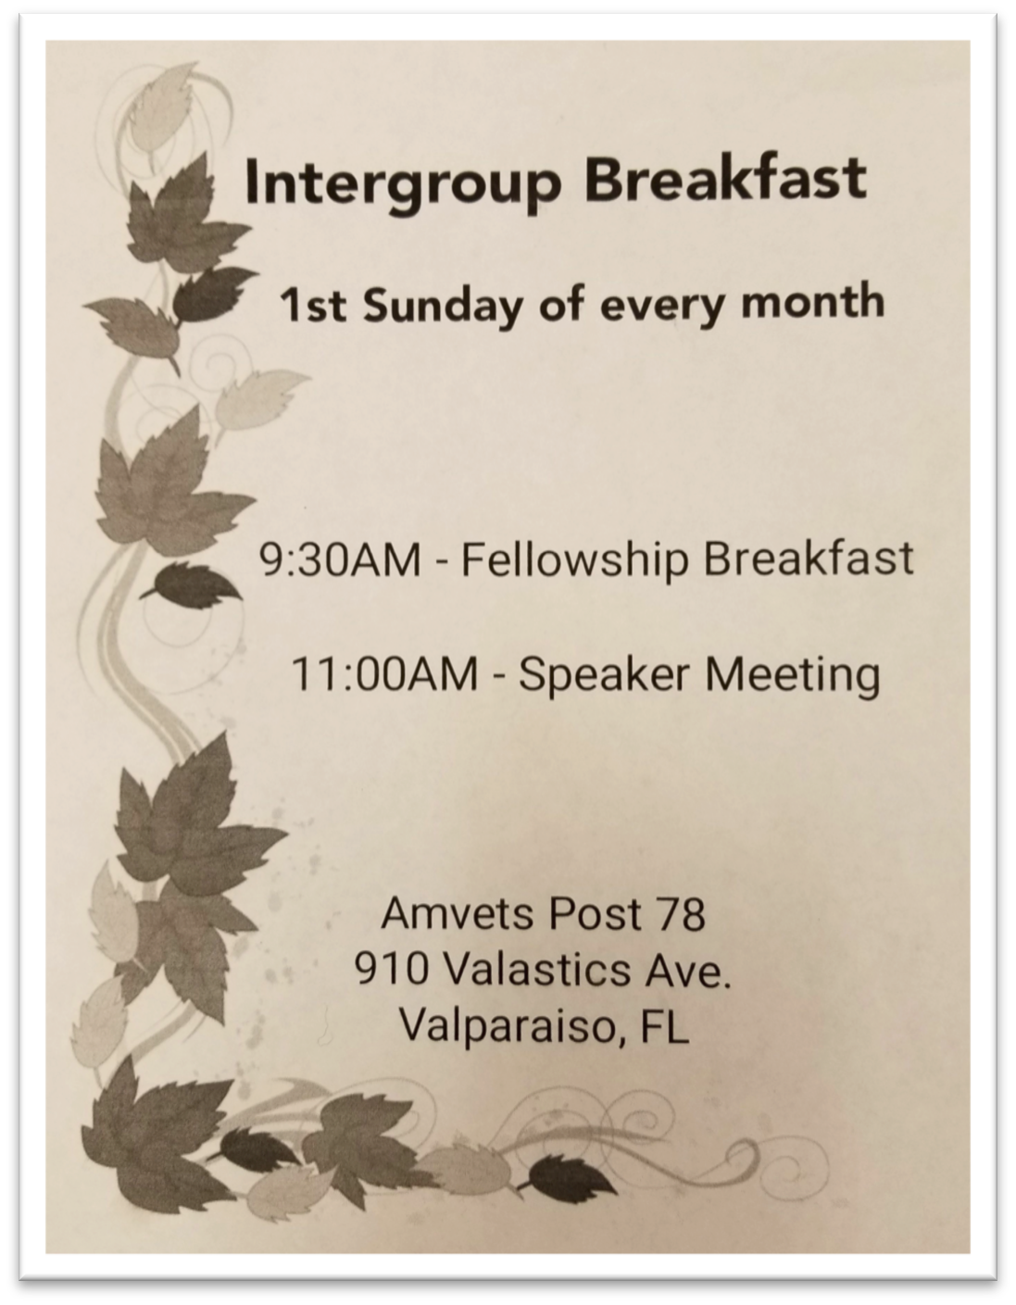
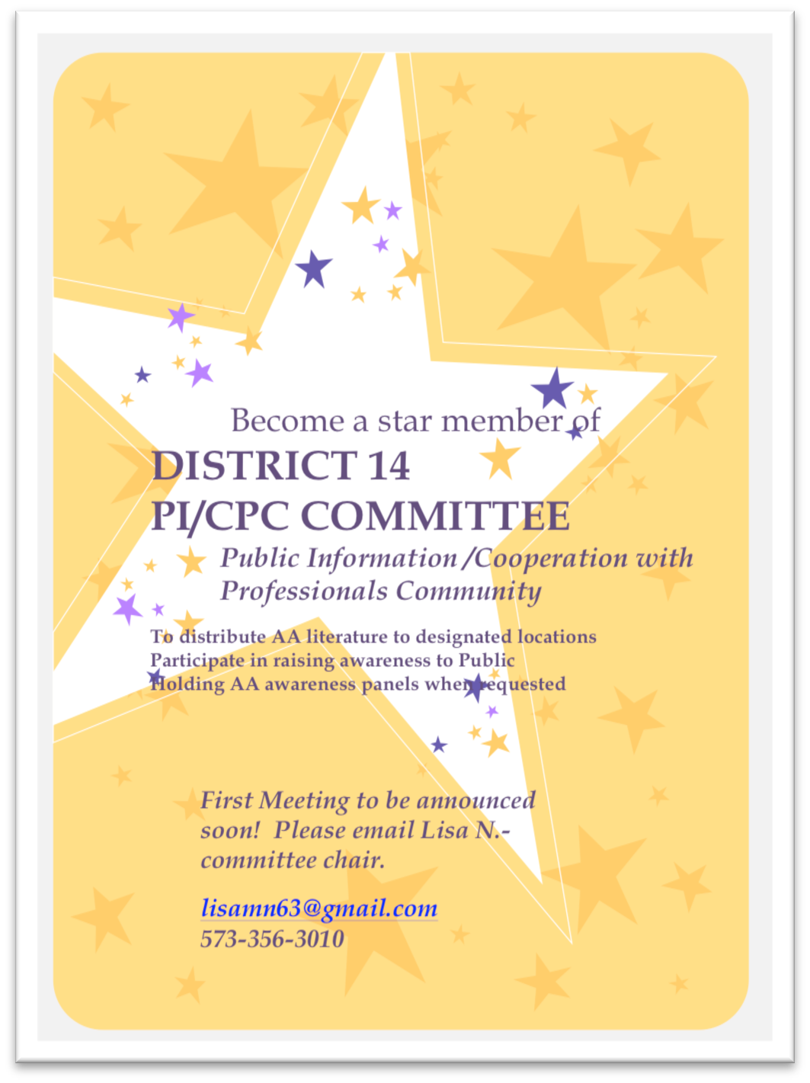
Share the Message
If you would like to be featured in our newsletter please send your articles, jokes, birthdays, and announcements to infoandnews@centurylink.net
*Content submitted may edited*
24 Hollywood SW, Suite 3,
Fort Walton Beach, Florida 32548 (850) 244-2421
centraloff@centurylink.net www.fortwaltonbeachaa.org

May 20th, 2019 Intergroup Committee Minutes

Tradition 2: For our group purpose there is but one ultimate authority;
a loving God as He may express Himself in our group conscience. Our
leaders are but trusted servants, they do not govern.

Tradition 9: AA, as such, ought never be organized, but we may create service
boards or committees directly responsible to those they serve.

In Attendance: Wes P. I.G. Chairman Judy C. Alkathon/Office Coordinator
Johnnie C. Secretary Katy S. Incoming Treasurer
Anita S. Busters Don H. Straight Up Group
Todd A. Miracle Group Sara P. Baker Group
Krysta H. But for Grace
Bob McC. DCM
Meeting opened with Serenity Prayer,Traditions2 & 9.

Secretary report given and accepted.
Treasury report given by Wes and accepted.
Office Coordinator report given by Judy and accepted.

All desk shifts are presently manned. Still need backups to cover
shifts when needed.
Webmaster/newsletter editor Megan will be stepping down to return to school.

Katy S. will be stepping in as Intergroup Treasurer. Thanks to Katy.

District Treasurer Debra confirmed District 14 mailing address
is unchanged.

The Baker group will be hosting the September Alkathon.

DCM report given by Bob McC. He asked that everyone support the Area Delegate
report to be given June 30th,3-5 p.m. at the Camel Club.

Krysta asked about forwarding office phone to volunteers on rotation rather
than using the answering service. It was decided to take the matter to the
groups for discussion.

Group reports were given by all present.

The Friday Night Ladies meeting in Fort Walton and the Southside group
in Crestview have been cancelled.

Respectfully submitted. Johnnie Clark

Central Office Intergroup 24 Hollywood Blvd SW Suite 3
Ft Walton Beach, FL 32548 850-244-2421
offcord@centurylink.net
REQUIREMENTS and APPLICATION FOR TRUSTED SERVANT AT AA CENTRAL OFFICE

- Full name, printed:

- Date of application:

- Permanent Address :

- Phone: Mobile: Other:

- Email Address:

Must have 1 -2 years of continuous sobriety!

- Sobriety date:

- Name of sponsor: Phone:

- Home group name:

- Home group Secretary: name Phone:

- Must be an active member of AA, in Area 1, District 14 for minimum of 1 year: (may be waived per IG Chair)
- Days or times you may or may not be available:

Contact Judy C 850-974-0890 or Wes P. 850-585-3203

Issue #: [Date]
Dolor Sit Amet

ALKATHON
HOSTED BY RULE 62 GROUP

Saturday JUNE 29TH
FIRTST PRESBYTERIAN CHURC

5PM FELLOWSHIP

5:30PM PULLED PORK DINNER

6PM ALANON SPEAKER/TBD

7PM AA SPEAKER PETER S FROM PENSACOLA

